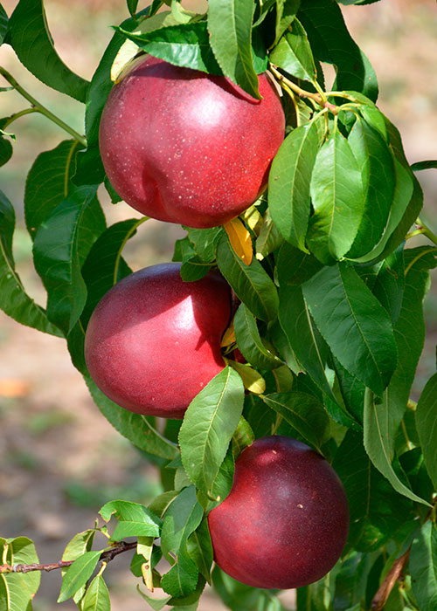 |  | Nectarine  Variety – Honey Sugar  Picking date – 15-25 June  Shape – Round  Firmness – Very good  Cracking – No  Skin color – Bright dark red  Flesh – Yellow  Size – AA  Sugar level – 14° Brix
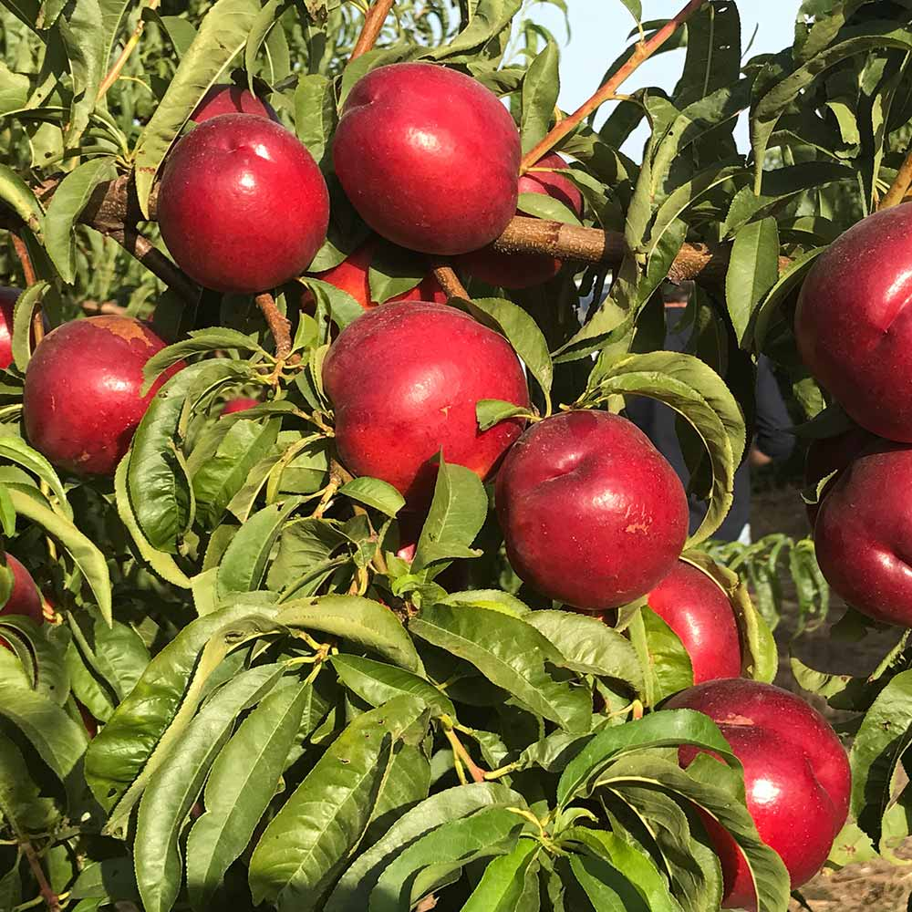 |  | Nectarine  Variety – Kinolea  Picking date – 10-15 June  Shape – Round, elongated  Firmness – Very good  Cracking – No  Skin color – Red  Flesh – Yellow  Size – AA  Sugar level – 16° Brix
 |  | Nectarine  Variety – Honey Top  Picking date – 25-30 June  Shape – Round  Firmness – Very good  Cracking – No  Skin color – Red  Flesh – Yellow  Size – AA  Sugar level – 15° Brix
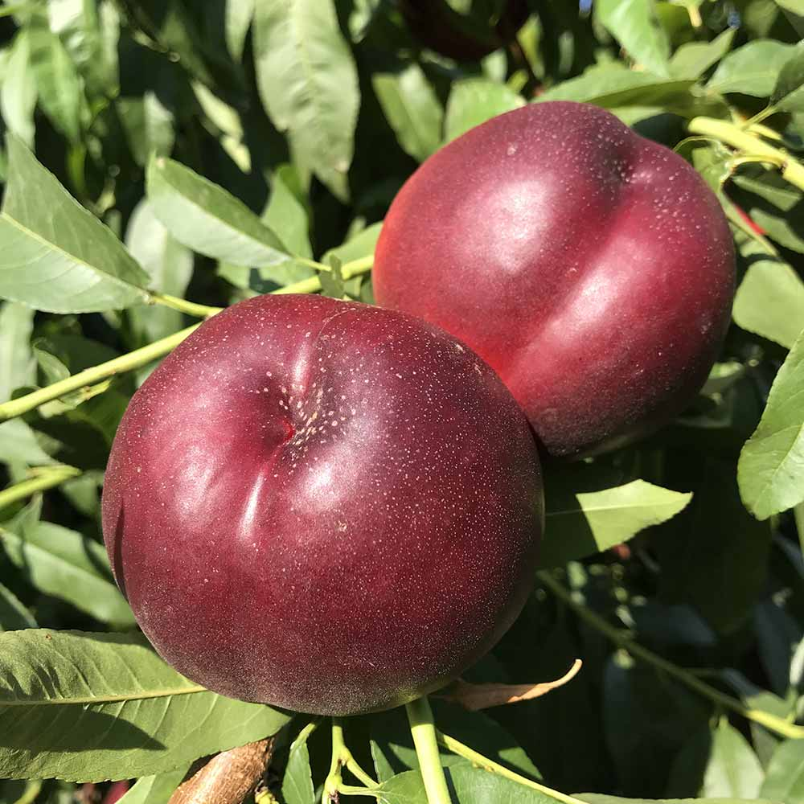 |  | Nectarine  Variety – Luciana  Picking date – 01-10 July  Shape – Round  Firmness – Very good  Cracking – No  Skin color – Dark red  Flesh – Yellow  Size – AA  Sugar level – 15° Brix
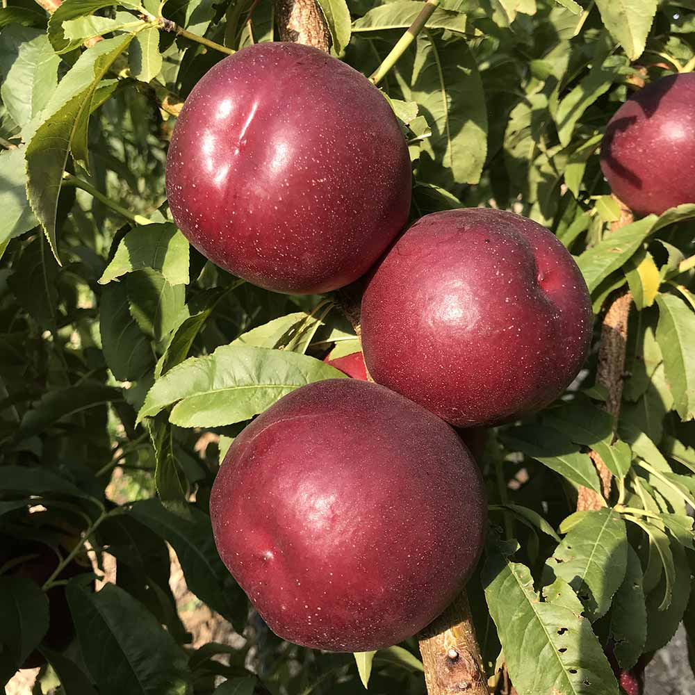 |  | Nectarine  Variety – Clariss  Picking date – 15-25 July  Shape – Round  Firmness – Very good  Cracking – No  Skin color – Dark red  Flesh – Yellow  Size – AA  Sugar level – 14° Brix
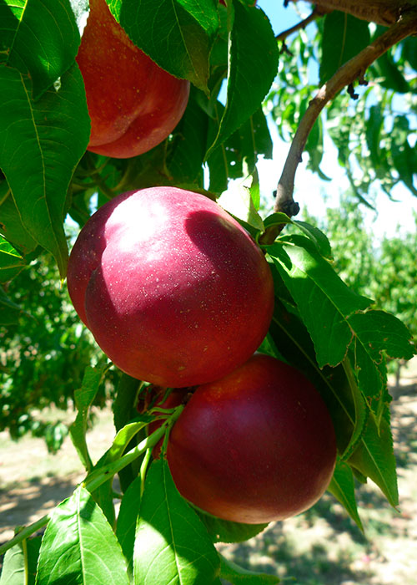 |  | Nectarine  Variety – Conquete  Picking date – 01-10 August  Shape – Round  Firmness – Very good  Cracking – No  Skin color – Dark red  Flesh – Yellow  Size – AA  Sugar level – 16° Brix

